**Sprint-3**

|  |  |
| --- | --- |
| Team ID | PNT2022TMID27677 |
| Project Name | Smart Fashoin Recommender Application |
| Team Membes | B.Nandita  Faustina Philomena Fernado  S.Aarthi  G.V.Leaaka shree |

1. Create a Bucket in IBM object storage.

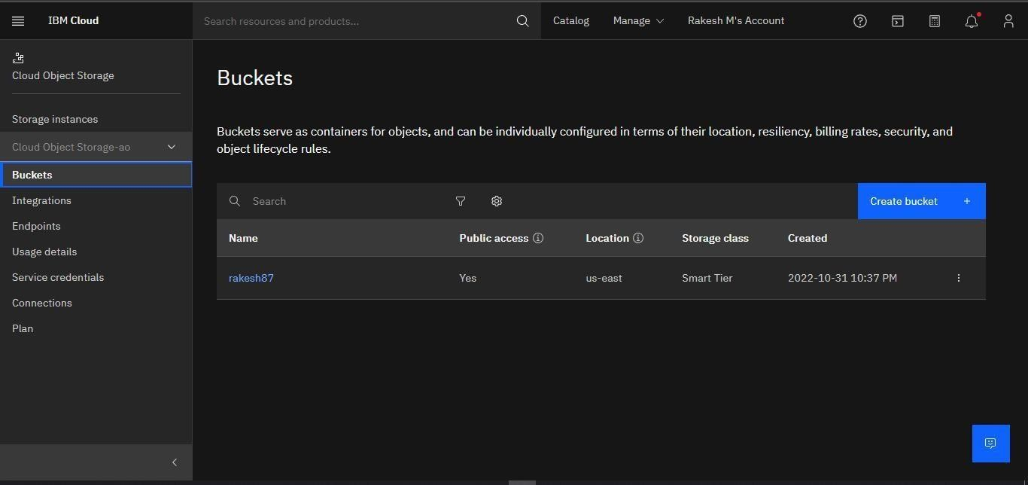

1. Upload an 5 images to ibm object storage and make it public. write html code to displaying all the 5 images.

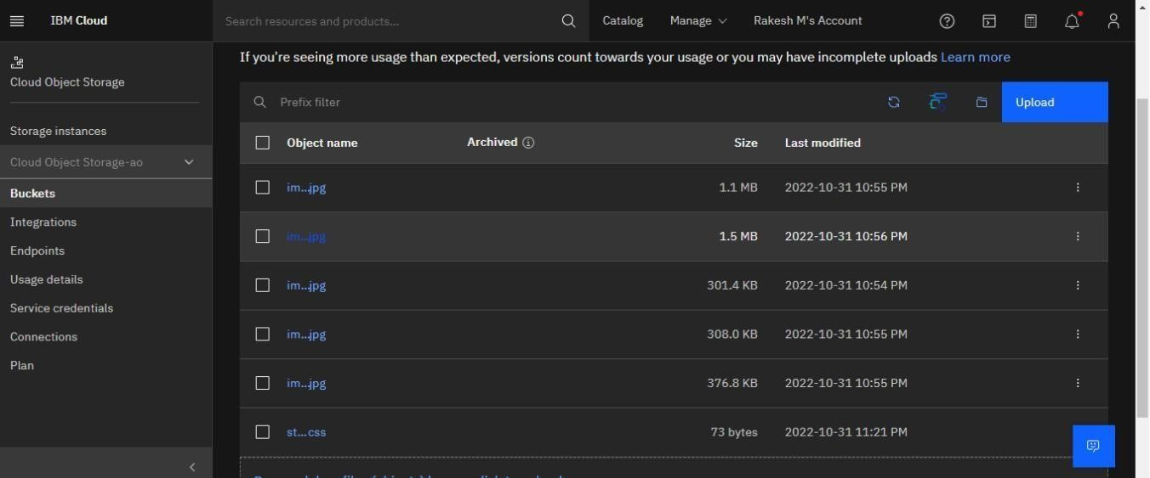

# Assignment3.html

|  |
| --- |
| <!DOCTYPE html>  <html lang="en">  <head>  <meta charset="UTF-8">  <meta http-equiv="X-UA-Compatible" content="IE=edge">  <meta name="viewport" content="width=device-width, initial-scale=1.0"> |
| <title>Document</title>  <link rel="stylesheet" href="https://rakesh87.s3.us-east.cloud-object- storage.appdomain.cloud/style.css">  </head> <body>  <img src="https://rakesh87.s3.us-east.cloud-object- storage.appdomain.cloud/img1.jpg" alt="">  <img src="https://rakesh87.s3.us-east.cloud-object- |
| storage.appdomain.cloud/img2.jpg" alt="">  <img src="https://rakesh87.s3.us-east.cloud-object- storage.appdomain.cloud/img3.jpg" alt="">  <img src="https://rakesh87.s3.us-east.cloud-object- |
| storage.appdomain.cloud/img5.jpg" alt="">  <img src="https://rakesh87.s3.us-east.cloud-object- storage.appdomain.cloud/img4.jpg" alt="">  </body>  </html> |

3. Upload a css page to the object storage and use the same page in your HTML code.

Style.css

img{ text-align: center; height:250px; width:250px;

}

# Assignment3.html

|  |
| --- |
| <!DOCTYPE html>  <html lang="en">  <head> |
| <meta charset="UTF-8">  <meta http-equiv="X-UA-Compatible" content="IE=edge">  <meta name="viewport" content="width=device-width, initial-scale=1.0">  <title>Document</title>  <link rel="stylesheet" href="https://rakesh87.s3.us-east.cloud-object- storage.appdomain.cloud/style.css">  </head>  <body> |
| <img src="https://rakesh87.s3.us-east.cloud-object- storage.appdomain.cloud/img1.jpg" alt="">  <img src="https://rakesh87.s3.us-east.cloud-object- storage.appdomain.cloud/img2.jpg" alt="">  <img src="https://rakesh87.s3.us-east.cloud-object- |
| storage.appdomain.cloud/img3.jpg" alt="">  <img src="https://rakesh87.s3.us-east.cloud-object- storage.appdomain.cloud/img5.jpg" alt="">  <img src="https://rakesh87.s3.us-east.cloud-object- |
| storage.appdomain.cloud/img4.jpg" alt="">  </body>  </html> |

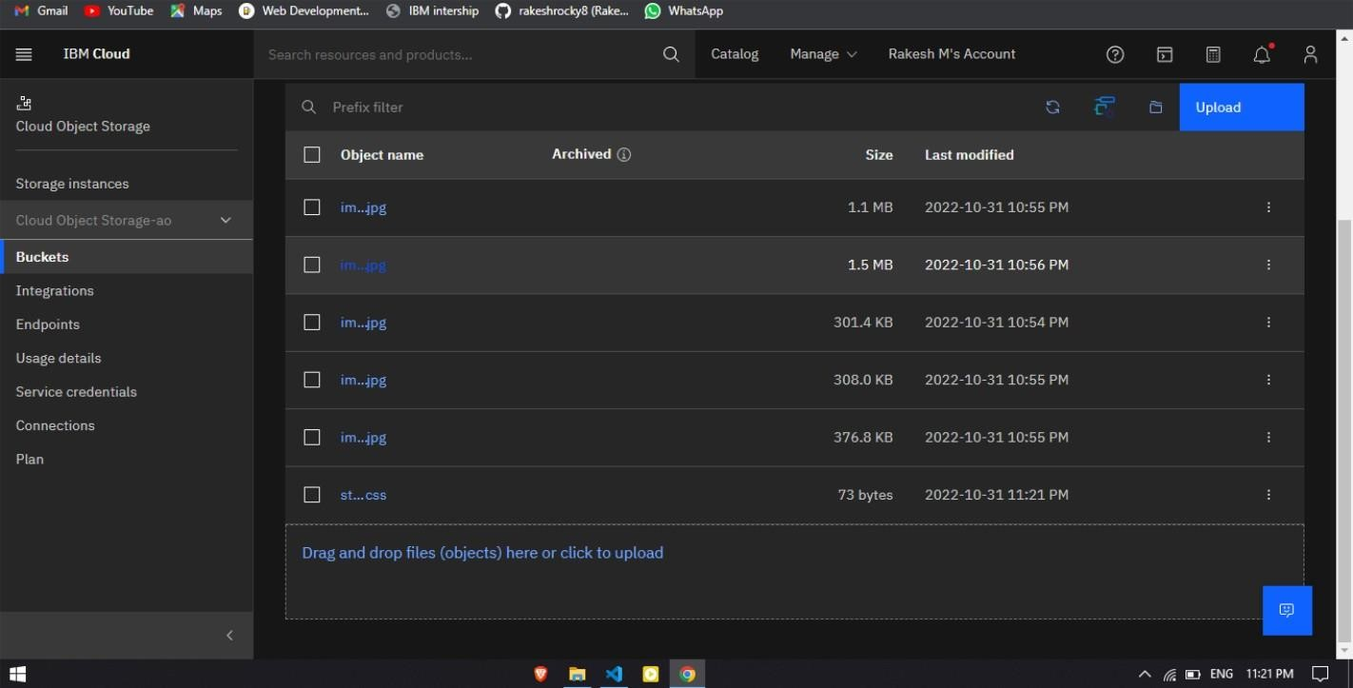

1. Design a chatbot using IBM Watson assistant for hospital. Ex: User comes with query to know the branches for that hospital in your city. Submit the web URL of that chat bot as a assignment.

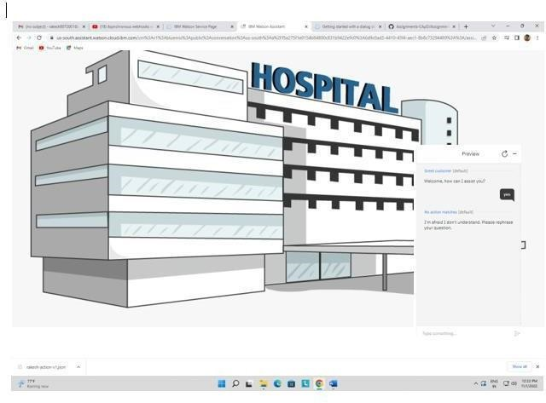

1. Create Watson assistant service with 10 steps and use 3 conditions in it. Load that script in HTML page.

